Grove - Infrared Reflective Sensor

|  |
| --- |
| **Contents**   [[hide](javascript:toggleToc())]   * [1 Introduction](http://www.seeedstudio.com/wiki/Grove_-_Infrared_Reflective_Sensor#Introduction) * [2 Features](http://www.seeedstudio.com/wiki/Grove_-_Infrared_Reflective_Sensor#Features) * [3 Specification](http://www.seeedstudio.com/wiki/Grove_-_Infrared_Reflective_Sensor#Specification) * [4 Interface Function](http://www.seeedstudio.com/wiki/Grove_-_Infrared_Reflective_Sensor#Interface_Function) * [5 Usage](http://www.seeedstudio.com/wiki/Grove_-_Infrared_Reflective_Sensor#Usage)   + [5.1 Demo 1: Line Following](http://www.seeedstudio.com/wiki/Grove_-_Infrared_Reflective_Sensor#Demo_1:_Line_Following)   + [5.2 Demo 2: Rotary Speed Detection](http://www.seeedstudio.com/wiki/Grove_-_Infrared_Reflective_Sensor#Demo_2:_Rotary_Speed_Detection) * [6 Resources](http://www.seeedstudio.com/wiki/Grove_-_Infrared_Reflective_Sensor#Resources) * [7 Support](http://www.seeedstudio.com/wiki/Grove_-_Infrared_Reflective_Sensor#Support) |

Introduction

The reflectivity of infrared light varies with the color and distance of the reflecting surface. According to this principle, Grove - Infrared Reflective Sensor utilizes a RPR220 reflective photosensor module to detect color and distance. When a light-colored object approaches,the signal intensity received by infrared reflective sensor increases and the indicator LED on board turns red. When a dark-colored object approaches, the intensity decreases and the LED turns off. This sensor is a basic and widely used part in applications such as line-following cars, rotary speed detection, auto data logging on utility meters or other situations where color or distance contrast is sharp.

Model:[WLS07061P](http://www.seeedstudio.com/depot/grove-infrared-reflective-sensor-p-1230.html?cPath=144_149)

[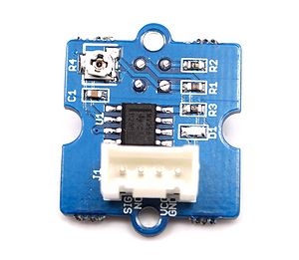](http://www.seeedstudio.com/wiki/File:Infrared_Reflective_Sensor-1.JPG) [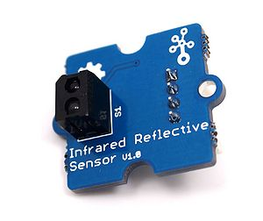](http://www.seeedstudio.com/wiki/File:Infrared_Reflective_Sensor-3.JPG)

Features

* High resolution sensor
* Indicator LED on board
* Sensitivity adjustable via potentiometer
* Small Grove 1X1 compatible interface

Specification

|  |  |  |  |  |
| --- | --- | --- | --- | --- |
| **Item** | **Min** | **Typical** | **Max** | **Unit** |
| **Voltage** | 4.5 | 5.0 | 5.5 | V |
| **Current** | 14.69 | 15.00 | 15.35 | mA |
| **Effective Distance** | 4 | / | 15 | mm |
| **Detectable Length(black line)** | 1 | / | / | mm |

Interface Function

[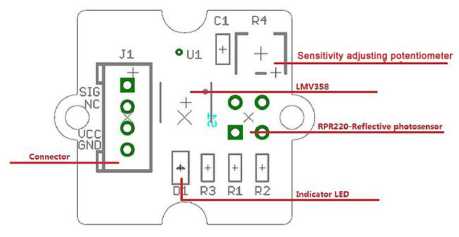](http://www.seeedstudio.com/wiki/File:Infrared_Reflective_Sensor-2.jpg)

**RPR220-Reflective photosensor**: High resolution Infrared Reflective sensor.

**LMV358**: Rail-to-Rail Operational Amplifier.

**Indicator LED**: The LED will turn on when the received infrared light intensity exceeds a preset level.

**Sensitivity adjusting potentiometer**: adjust the light threshold of the sensor.

To get more information about Infrared Reflective Sensor, please check out our source file: [Infrared Reflective Sensor Source Files](http://www.seeedstudio.com/wiki/File:Grove_-_Infrared_Reflective_Sensor_v1.0_SourceFile.zip)

Usage

Let's test the functions of Infrared Reflective Sensor with the following examples.

**Demo 1: Line Following**

This sensor can be used to help a robot car follow a black line on white background or vice versa.

1. Calibration   
Hold the sensor 12mm or other height you need above the background.

[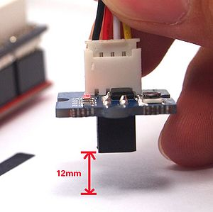](http://www.seeedstudio.com/wiki/File:Infrared_Reflective_Sensor-4.JPG)

Then adjust the potentiometer with a crosshead screwdriver until the indicator LED turns on.

[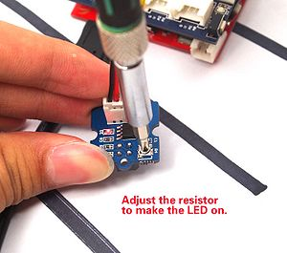](http://www.seeedstudio.com/wiki/File:Infrared_Reflective_Sensor-5.JPG)

After that, keep the distance and move the sensor horizontally above the black line. if the indicator LED goes off, job done.

[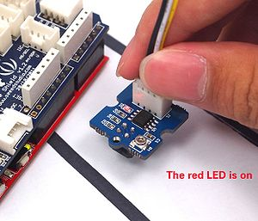](http://www.seeedstudio.com/wiki/File:Infrared_Reflective_Sensor-6.JPG)

[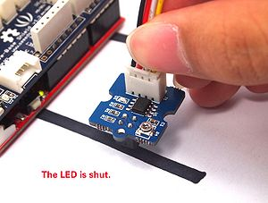](http://www.seeedstudio.com/wiki/File:Infrared_Reflective_Sensor-7.JPG)

If the LED remains on, adjust the potentiometer again until it's off.

**Demo 2: Rotary Speed Detection**

let's detect the speed of a motor via this example.

1. Connect the Infrared Reflective Sensor onto the D2 port of Grove - Base Shield like this.

[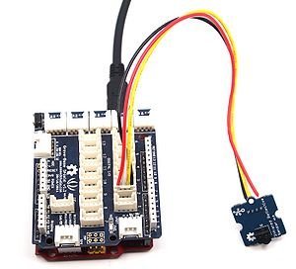](http://www.seeedstudio.com/wiki/File:Infrared_Reflective_Sensor-11.JPG)

2. Run up a motor

[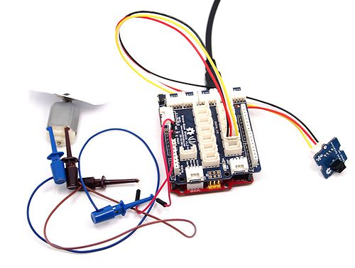](http://www.seeedstudio.com/wiki/File:Infrared_Reflective_Sensor-8.JPG)

**Note:**Add a white plate with a black line marked onto the motor so that the sensor can get one signal when the plate rotates a round.  
[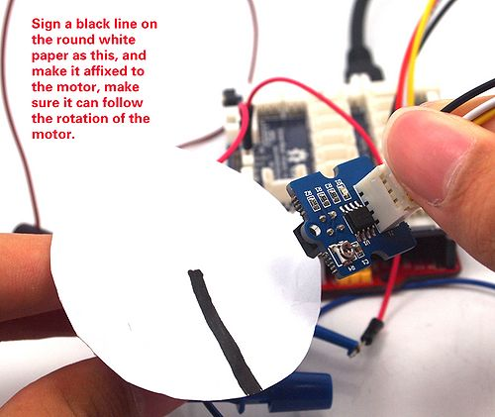](http://www.seeedstudio.com/wiki/File:Infrared_Reflective_Sensor-9.JPG)   
3. Download the library: [Arduino timer1 library](http://www.seeedstudio.com/wiki/File:TimerOne-ArduinoLib.zip) and unzip it into the libraries file of Arduino IDE by the path: ..\arduino-1.0.1\libraries.  
4. Upload the demo code to your Arduino/Seeeduino. If you do not know how to upload ,please click [here](http://www.seeedstudio.com/wiki/Upload_Code).

#include <TimerOne.h>

unsigned int counter=0;

void blink()

{

counter++;

}

void timerIsr()

{

Timer1.detachInterrupt(); //disable the timer1

Serial.print("The speed of the motor: ");

Serial.print(counter,DEC);

Serial.println("round/s");

counter=0;

Timer1.attachInterrupt( timerIsr ); //enable the timer1

}

void setup()

{

Serial.begin(9600);

Timer1.initialize(1000000); // set a timer of length 1sec

attachInterrupt(0, blink, RISING); //INT0

Timer1.attachInterrupt( timerIsr ); // attach the service routine here

}

void loop()

{

 ; //do nothing

}

5. Open the Serial Monitor to read the data.

[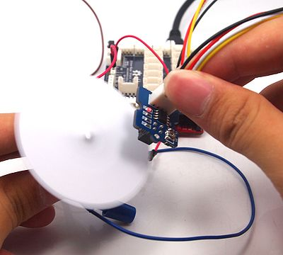](http://www.seeedstudio.com/wiki/File:Infrared_Reflective_Sensor-10.JPG)

[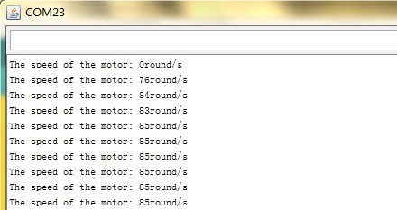](http://www.seeedstudio.com/wiki/File:Infrared_Reflective_Sensor-12.JPG)

Resources

* [Grove-Infrared Reflective Sensor Eagle Files](http://www.seeedstudio.com/wiki/File:Grove_-_Infrared_Reflective_Sensor_v1.0_SourceFile.zip)
* [Arduino Timer1 Library](http://www.seeedstudio.com/wiki/File:TimerOne-ArduinoLib.zip)
* [RPR220 Datasheet](http://www.seeedstudio.com/wiki/File:RPR220_datasheet.pdf)